Lab 10
Deploying a Predictive Model with KServe on Minikube
1. Install and configure KServe on a local Kubernetes cluster (Minikube)
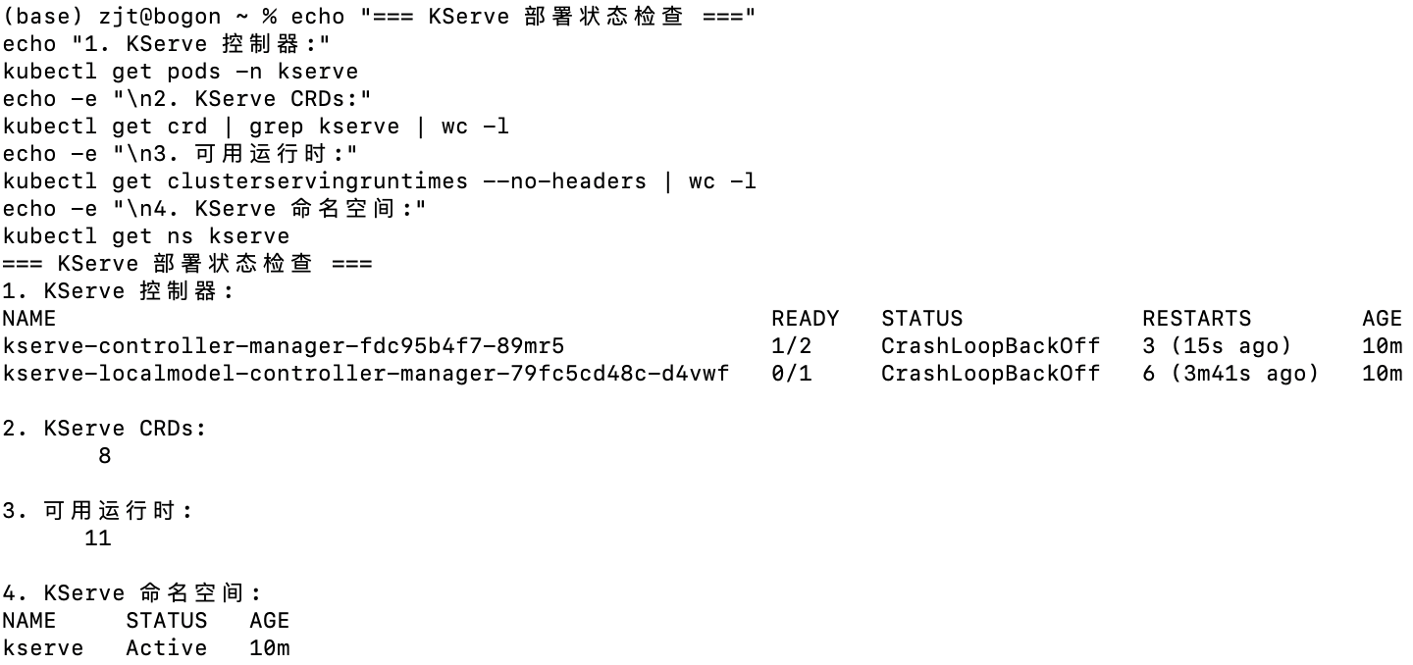
2. Deploy a predictive model using a KServe InferenceService
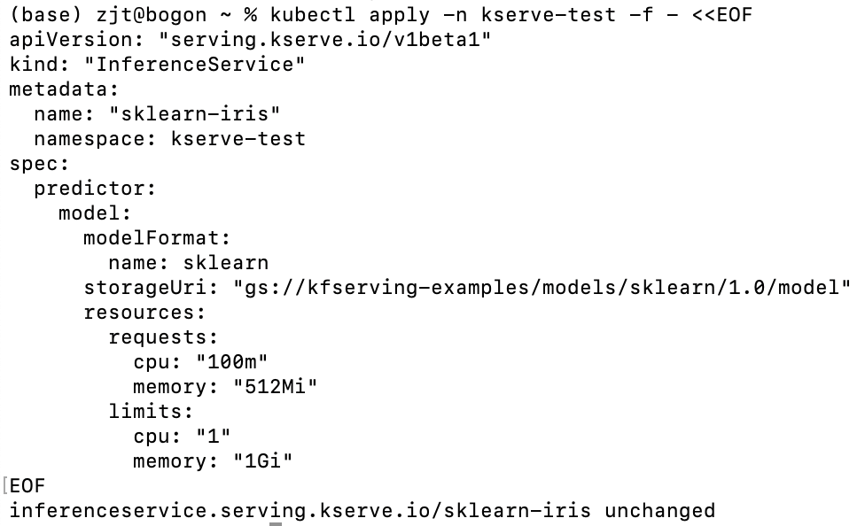
3. Monitor the status of the service and debug common issues
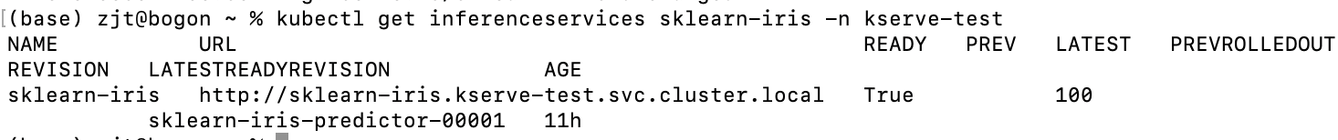
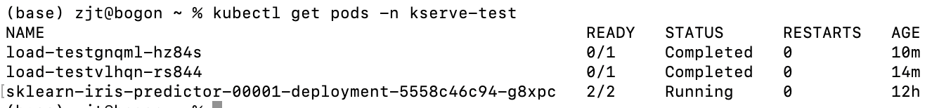
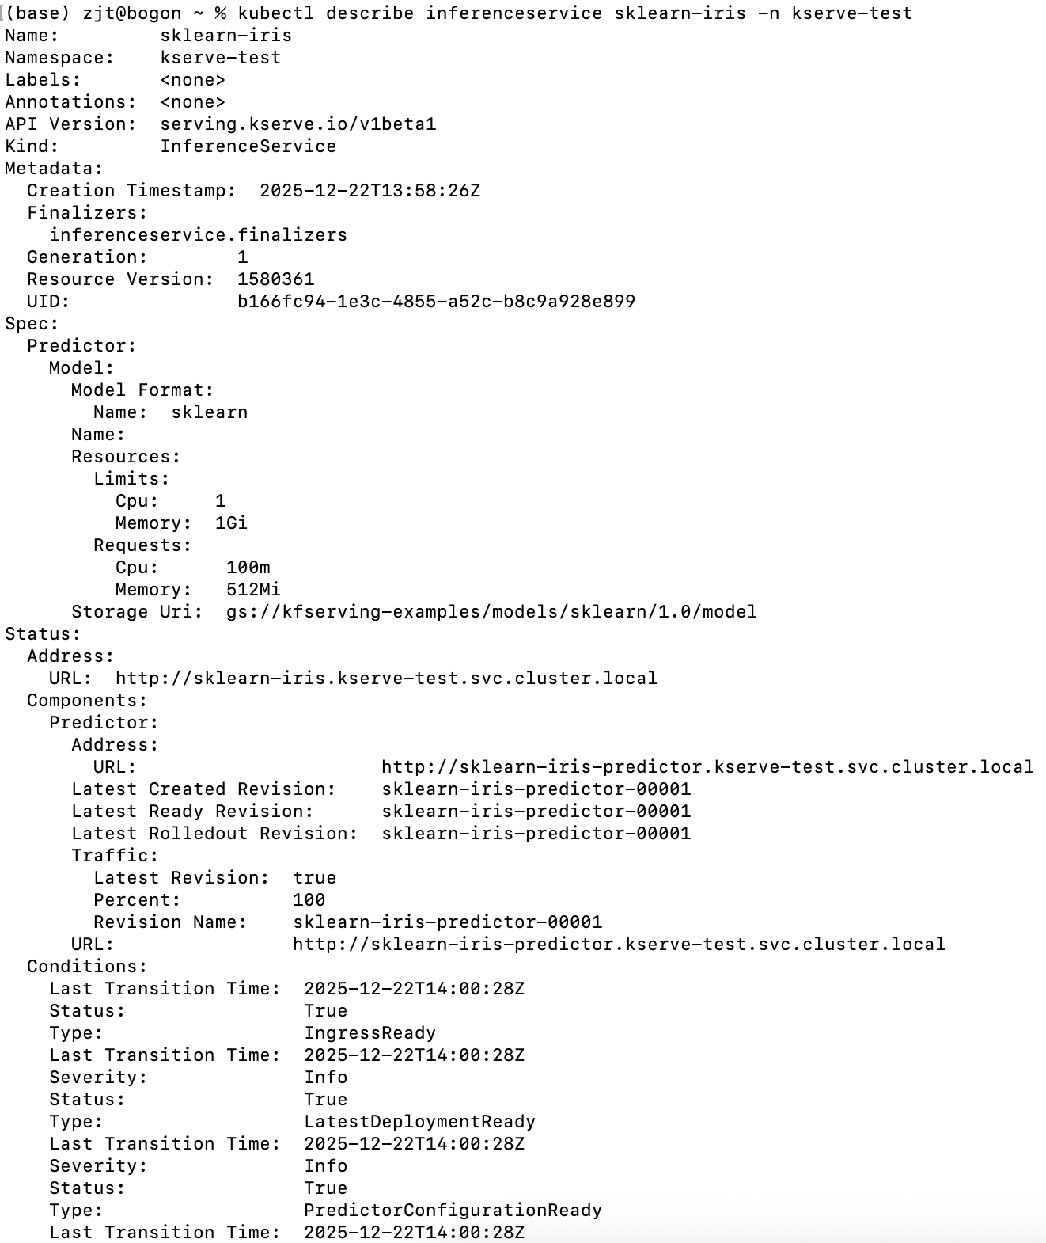
4. Find out how to reach the InferenceService from outside the cluster.
5. Send inference requests and interpret results
